**Practical – 1**

**Aim: -** Design PHP based web pages using correct PHP, CSS, and XHTML syntax, structure.

**Code: -**

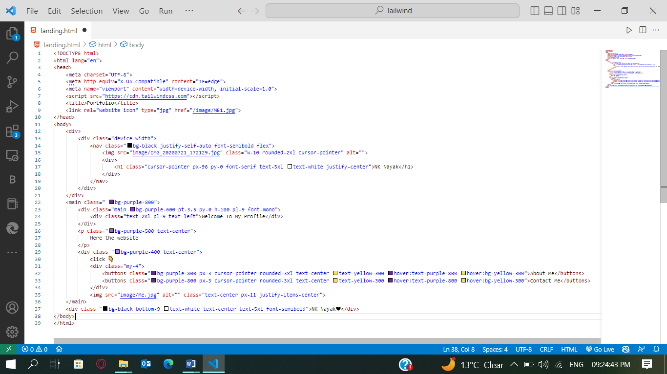

**Output: -**

